**Polymorphism EG. 2： Circle and its Subclasses**

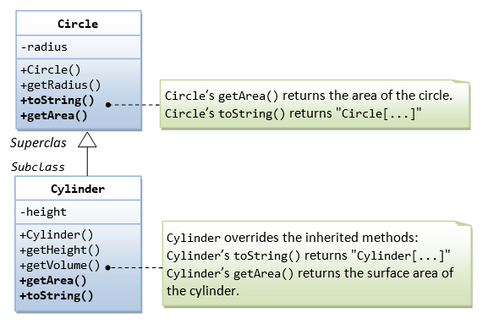

**Write a test driver to test all methods of Circle and Cylinder**

**Ex: The Circle and Cylinder Classes Using Composition**

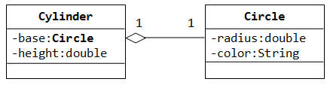

Try rewriting the Circle-Cylinder of the previous exercise using *composition* (as shown in the class diagram) instead of *inheritance*. That is, "a cylinder is composed of a base circle and a height".

**Write a test driver to test all methods of Circle and Cylinder**

**Which design (inheritance or composition) is better?**